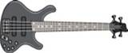
JFT
PARTY
BAND!

Performing the Greatest Classic Hits of All Time!
Interactive Entertainment Everybody Can Be A Part Of!

